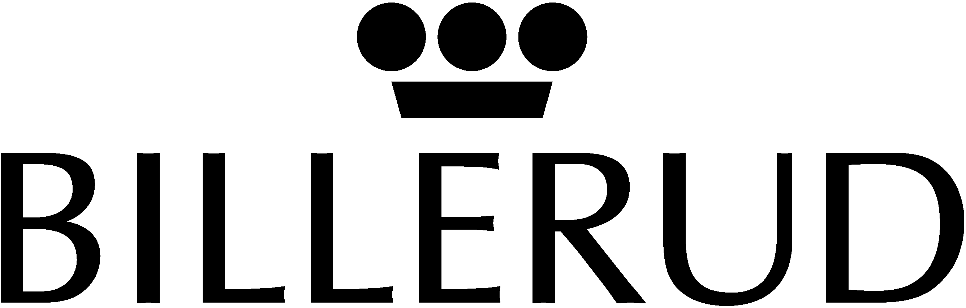 PRESS RELEASE
_________________________________________________________________________________
www.billerud.com
2003-09-22

Write-down of share capital

On 6 May 2003 the Billerud AB’s Annual General Meeting decided to write down the company’s share capital with 4,831,000 already acquired shares. This write-down has now been carried out. Following the write-down, the share capital amounts to SEK 723, 874,975 and the total number of shares is 57,909,998, each of which is worth a nominal SEK 12.50.

As of 22 September 2003, shares are distributed as follows:
Total no. of registered shares 57,909,998

Shares bought back and owned by Billerud 1,443,000
Shares on the market 56,466,998

Convertible debenture (on full conversion 268,047
Shares on the market (after full conversion) 56,735,045

Stockholm 22 September 2003
Billerud AB (publ)

Bert Östlund
President & CEO

For further information, please contact:
Bert Östlund, President & CEO, +46 8 553 335 00 or +46 70 518 2757
Nils Lindholm; CFO, +46 8 553 335 07 or +46 70 217 5225

For further information about Billerud, please visit www.billerud.com.

