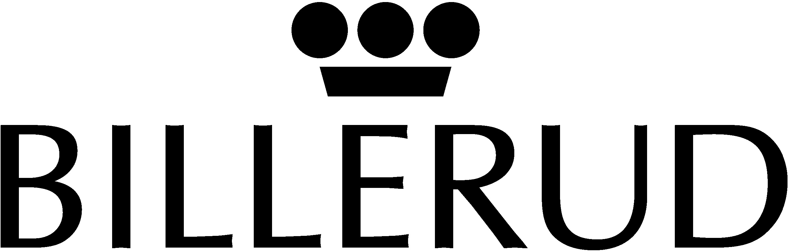 PRESS RELEASE
_________________________________________________________________________________
www.billerud.com
5 March 2002

Stock options to Billerud’s management

In its capacity as principal owner of Billerud AB, Stora Enso has issued a total of 300,000 stock options to nine members of Billerud’s management group.

The options, which have a term of five years, entitle the holder after three years to purchase one share in Billerud AB from Stora Enso for SEK 87 per share, provided he or she is still employed at Billerud. The exercise price was based on the share price on the day after Billerud’s year-end report, i.e. the price on 8 February 2002, plus 15%.

The issue of stock options does not entail any dilution of ownership for other shareholders or any cost to the company.

Stockholm, 5 March 2002
Billerud AB (publ)

Bert Östlund
President and CEO

For further information, please contact:
Ingvar Petersson, Chairman of the Board, +46 70 595 7605
Bo Eriksson, Stora Enso, +46 70 578 22 44
Bert Östlund, President and CEO, +46 8 553 335 00 or +46 70 518 2757

